KUBERNETES TASK-2
Task Description:
Create the K8s EKS, further you have to do the deployment of the Nginx application and access the application outside the cluster.
O/P:
- Install AWS CLI: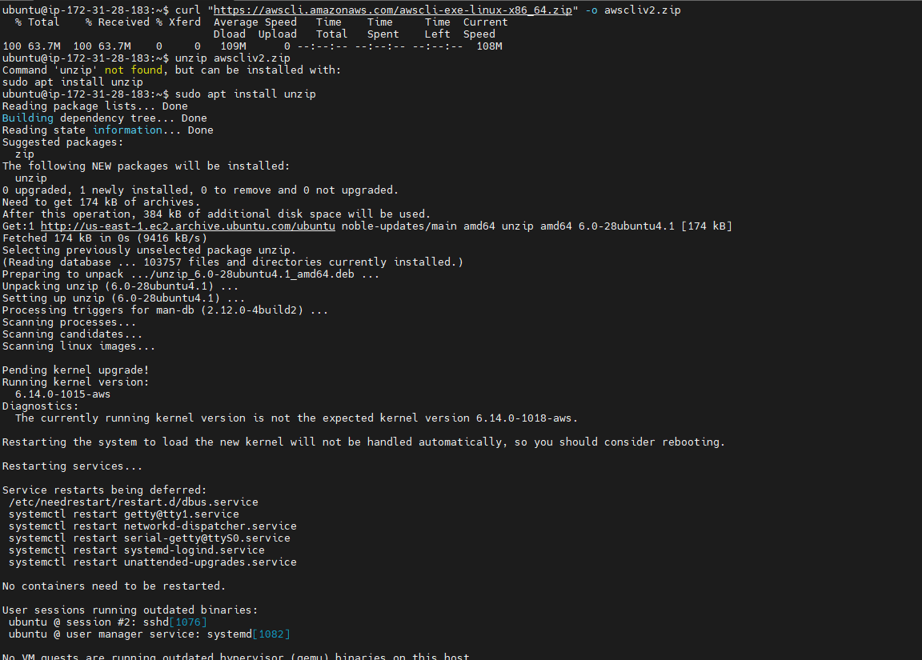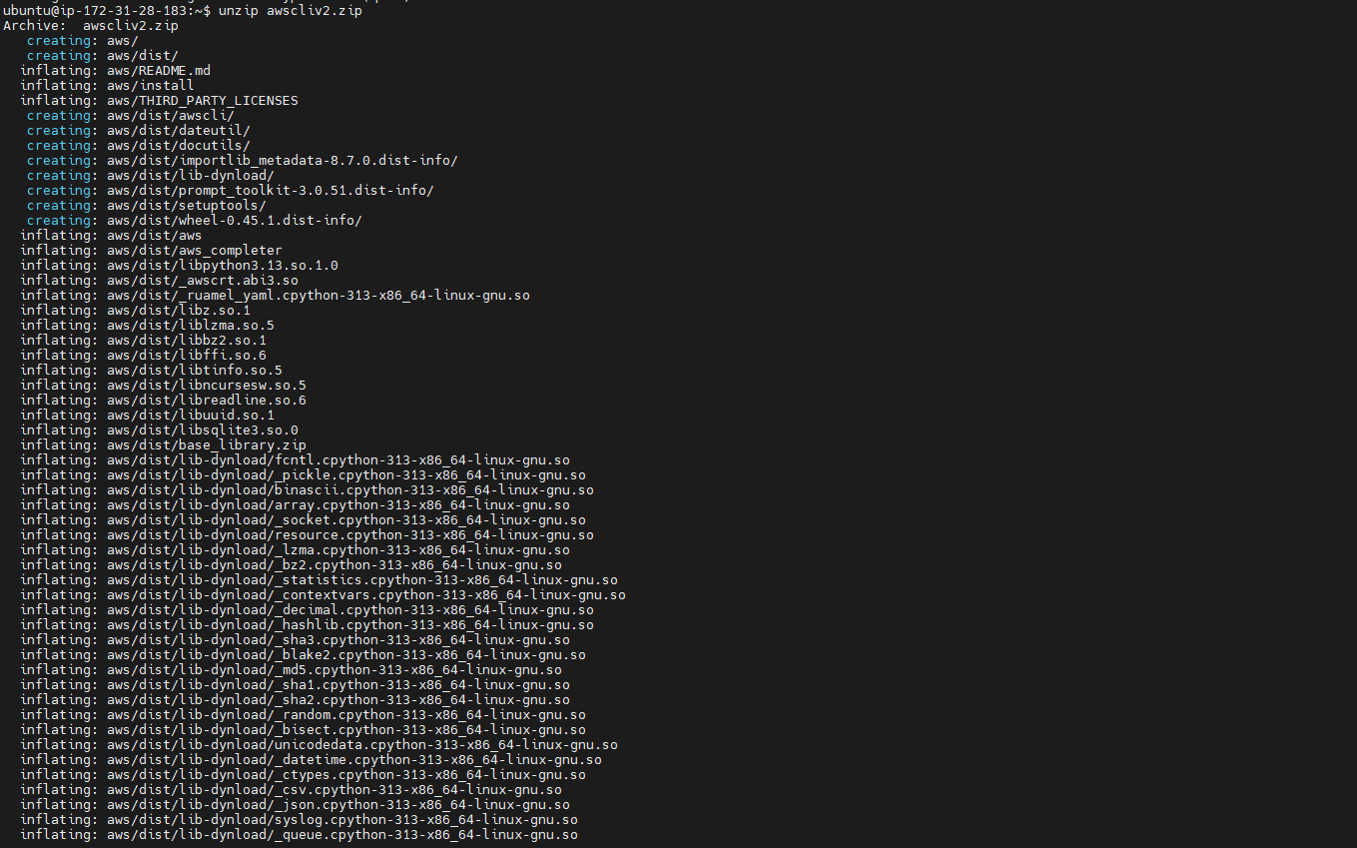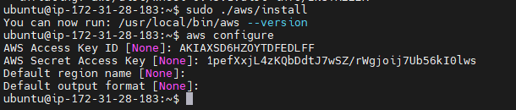
- Install kubectl:
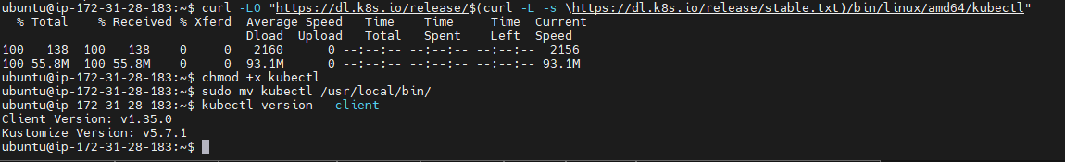
- Install eksctl:
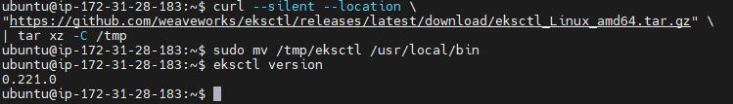
- Create EKS Cluster:
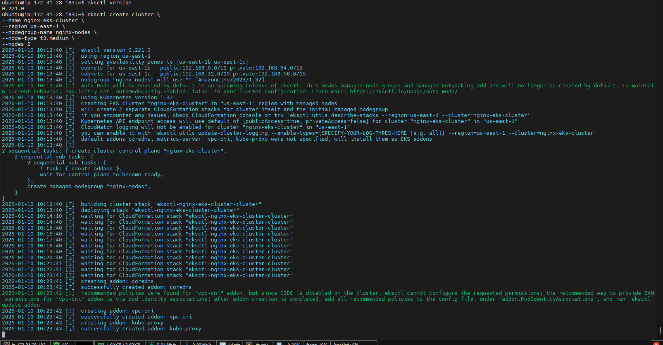
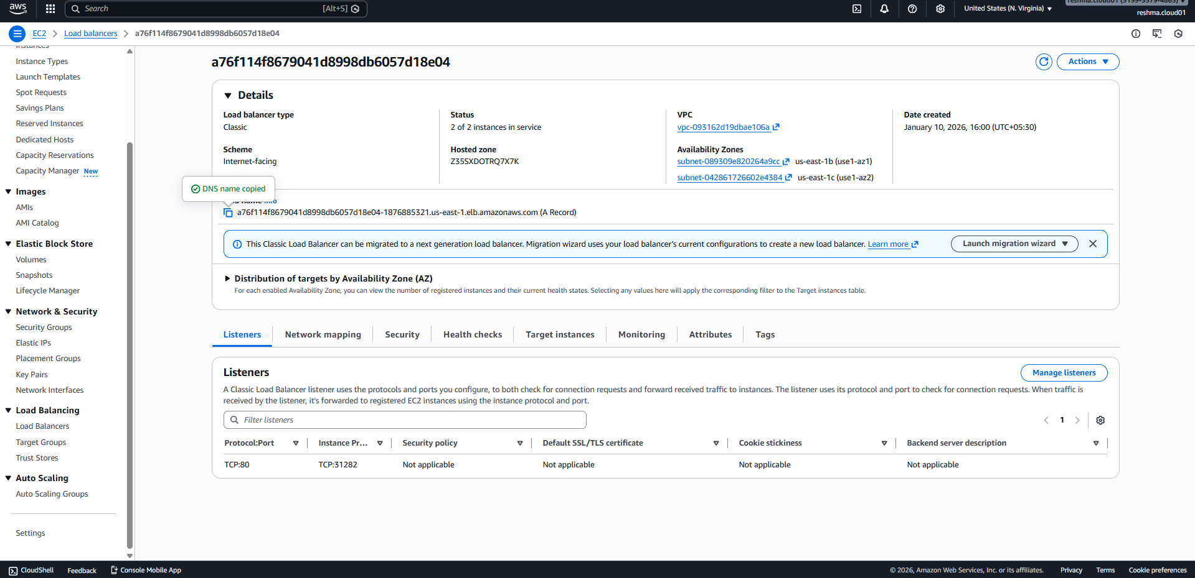
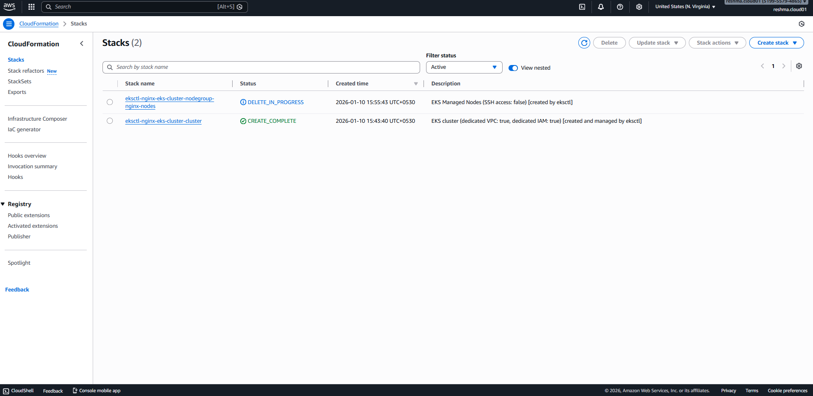
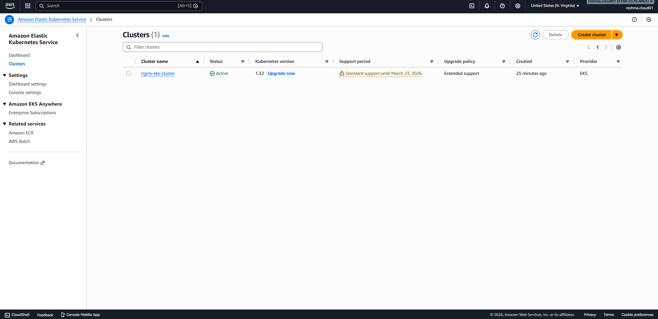
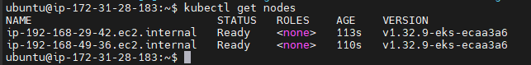
- Deploy Nginx Application:
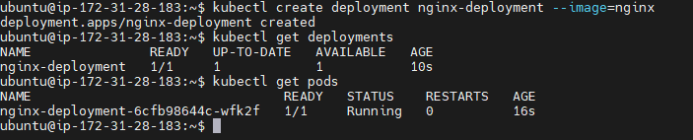
- Expose Nginx Outside the Cluster:
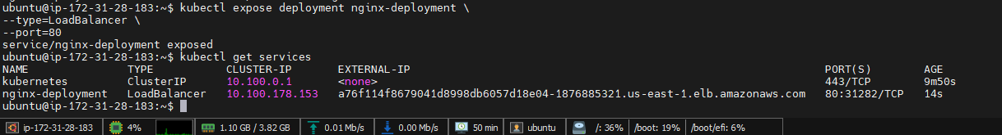
- Access Nginx from Browser:
